Comparative Analysis of Search Algorithms
in a Constrained Store Navigation Environment

BFS, DFS, UCS, and A* Performance on a 5-Lane Grocery Store Graph
Store Pathfinder: Interactive Turn-Based Game (v4.0) — Enhanced Edition
MLC Busy Local Grocery Store Simulation | AIMA Framework

1200 Simulated Base Games | 400 Weighted Experiment Games | 100 Games Per Config

Table of Contents

1. Abstract
This paper presents a comparative empirical analysis of three classical search algorithms—Breadth-First Search (BFS), Depth-First Search (DFS), and Uniform Cost Search (UCS)—applied to a competitive two-player store navigation problem. Using a custom-built interactive game simulation modeled after the AIMA framework (Russell & Norvig, 2021), we evaluate algorithm performance across 1200 automated games (100 per configuration) on a 5-lane grocery store graph with a permanently blocked aisle (A3), dynamic opponent blocking via banana-leaf barriers, and randomized item distributions. Our results demonstrate that BFS achieves the highest overall performance with a 59.1% win rate and an average of 38.8 moves to collect 12 items, while UCS produces functionally equivalent path quality at 41% higher computational cost. DFS proves categorically unsuitable, requiring 67.5 moves and winning 0.1% of games. We further introduce a novel Experiment 5 with weighted edges on the top step of Aisle 2 (T2↔A2, cost=3) and bottom step of Aisle 4 (B4↔A4, cost=3), which reveals that UCS achieves 15.5% lower weighted path cost than BFS while maintaining identical move counts—demonstrating the first measurable behavioral difference between BFS and UCS. We additionally analyze how the A* algorithm would perform (Elkari et al., 2024; Karur et al., 2021) and discuss conditions under which each algorithm excels in stores of varying size.

2. Introduction

2.1 Background and Motivation
Pathfinding algorithms form the backbone of intelligent navigation systems, from robotic warehouse automation to GPS route planning (Karur et al., 2021; Gao et al., 2024). While the theoretical properties of classical search algorithms are well-established, their practical performance in constrained, adversarial environments with dynamic obstacles remains an active area of study. As Syahputra et al. (2026) observe in their review of the transition from classical to heuristic search methods, BFS and DFS continue to serve as foundational baselines in modern AI applications even as the field moves toward more informed strategies. This research bridges the gap between textbook theory and real-world application by implementing these algorithms in a concrete, measurable scenario: competitive grocery shopping.
The grocery store navigation problem provides an ideal testbed for search algorithm comparison because it combines several realistic constraints: a structured but not trivial graph topology, permanently blocked regions simulating real-world aisle closures, dynamic adversarial obstacles where one player’s position blocks lanes for the other, randomized objectives requiring multi-target planning, and competitive pressure where efficiency directly determines the winner. Similar multi-target collection problems arise in warehouse robotics (Gao et al., 2024) and game AI environments (Perez-Liebana et al., 2019; Lu & Li, 2022).

2.2 Problem Statement
Given a graph representing a 5-lane grocery store with 17 navigable nodes, a permanently blocked aisle (A3), and two competing agents each assigned 12 randomly distributed products, determine which uninformed search algorithm—BFS, DFS, or UCS—most efficiently navigates the store to collect all assigned items while contending with dynamic blocking from the opposing agent. This formulation extends classical single-agent pathfinding (Gayathri, 2019; Karur et al., 2021) to a competitive multi-agent setting (Gao et al., 2024). Additionally, we seek to determine whether weighted edges can break the BFS–UCS equivalence observed on uniform-cost graphs. Specifically, we answer:
1. Which algorithm achieves the fewest moves to collect all 12 items?
2. How does the permanently blocked A3 aisle affect algorithm routing behavior?
3. Are BFS and UCS truly equivalent on uniform-cost graphs, and what is the overhead of UCS’s priority queue?
4. How do weighted edges on specific paths affect BFS vs UCS behavior and path cost? (NEW)

3. Game Description and Rules

3.1 Store Layout
The MLC Busy Local Grocery Store is modeled as an undirected graph with 17 nodes organized in three horizontal rows connected by vertical links. Two entrance nodes connect to the middle of the top and bottom rows respectively.
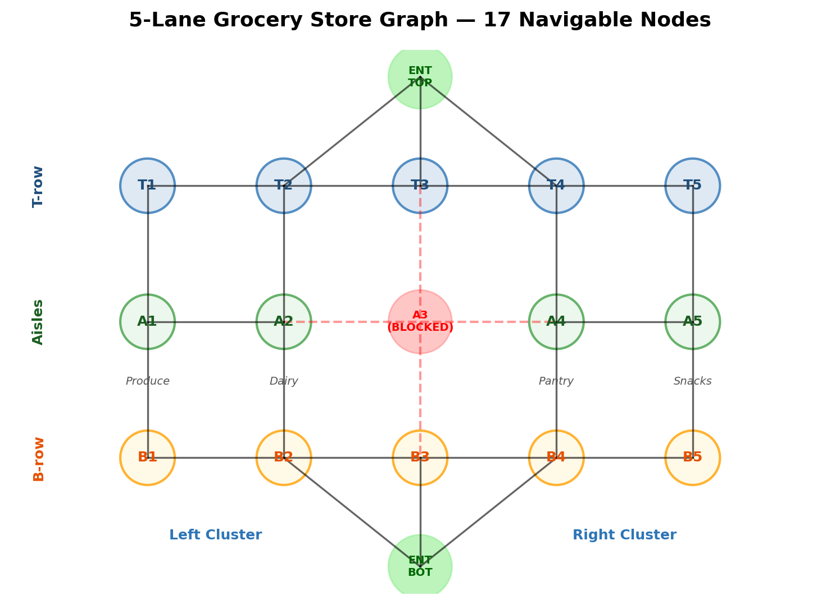
Figure 11: Store graph layout showing 17 navigable nodes, A3 permanently blocked, left and right clusters.
Each aisle node (except A3) connects vertically to its corresponding T-row and B-row nodes, and horizontally to adjacent aisles. All edges have uniform cost of 1 in the base graph. The A3 blockage splits the store into a left cluster (A1–A2, Produce and Dairy) and a right cluster (A4–A5, Pantry and Snacks), forcing all cross-cluster traffic through corridor chokepoints at T-row (T2–T4) or B-row (B2–B4).

3.2 Products and Assignment
Aisle | Category | Products
A1 | Produce | Apples, Bananas, Lettuce, Tomatoes, Carrots, Oranges
A2 | Dairy | Milk, Eggs, Cheese, Yogurt, Bread, Butter
A3 | Meat | PERMANENTLY CLOSED
A4 | Pantry | Rice, Pasta, Soup, Beans, Cereal, Coffee
A5 | Snacks | Chips, Cookies, Soda, Juice, Popcorn, Tea
At game start, the 24 products are randomly shuffled and split equally: Player A receives 12, Player B receives 12.

3.3 Game Rules
1. Players alternate turns. Each turn, a player may move to one adjacent node or wait.
2. Products auto-collect when a player enters the aisle node containing their assigned items.
3. Aisle A3 is permanently blocked. Neither player may enter A3.
4. Banana-leaf barrier: The opponent’s current position blocks that node dynamically, similar to the ghost-avoidance mechanic studied by Salem et al. (2024) in PAC-Man navigation and the adversarial blocking in game AI systems (Li & Zhang, 2025).
5. First player to collect all 12 items wins. Ties broken by move count.
6. Each player’s algorithm serves as both navigator and strategist.

4. Algorithm Descriptions

4.1 Breadth-First Search (BFS)
BFS explores nodes in order of distance from the start, using a FIFO queue. It evaluates all remaining products, searches for the shortest path to each aisle, and selects the nearest. Properties: Complete (yes), Optimal (yes, unweighted), Time O(b^d), Space O(b^d). Data structure: collections.deque with O(1) operations. As established by Elkari et al. (2024) and confirmed by Gayathri (2019), BFS guarantees the shortest path in unweighted graphs but requires O(b^d) space.

4.2 Depth-First Search (DFS)
DFS explores as deep as possible using a LIFO stack. Our implementation maintains a reached set (graph-search variant). Because DFS does not guarantee shortest paths, the product it selects as “closest” may not be nearest. Properties: Complete (yes, with reached set), Optimal (no), Time O(b^m), Space O(bm). Data structure: Python list as stack. Abbass et al. (2025) documented this same weakness in data center routing, where standard DFS produced suboptimal routes in structured network topologies. Gayathri (2019) further confirmed that DFS is the worst-case uninformed search for path optimality.

4.3 Uniform Cost Search (UCS)
UCS uses a priority queue ordered by cumulative path cost. On the uniform-cost base graph, UCS theoretically produces the same paths as BFS but with heap overhead. On the weighted graph (Experiment 5), UCS’s cost-sensitivity becomes its advantage. Properties: Complete (yes), Optimal (yes), Time O(b^(1+C*/ε)), Space O(b^(1+C*/ε)). Data structure: heapq min-heap with O(log n) operations. Syahputra et al. (2026) categorize UCS as a bridge between uninformed and informed search, while Gayathri (2019) established that UCS provides the optimal solution among uninformed algorithms when edge costs vary.

5. Experimental Methodology

5.1 Simulation Configuration
We ran 1200 total base games: 6 algorithm matchups × 2 entrance assignments × 100 trials per configuration, with deterministic seeding (base_seed=42) for reproducibility. Additionally, 400 weighted experiment games were run: 2 matchups × 2 entrances × 100 trials. Each game recorded metrics across five experiment categories. The base simulation completed in 33.56 seconds; the weighted experiment in 2.28 seconds. This approach follows the empirical comparison methodology used by Elkari et al. (2024), Salem et al. (2024), and Karur et al. (2021), where algorithms are evaluated on identical problem instances to ensure fair comparison.

5.2 Experiment Descriptions
Experiment 1 (Head-to-Head): Evaluates each algorithm pairing across both entrances. Core metrics: total moves, win/loss/tie, wait count, collection efficiency, detour ratio.
Experiment 2 (A3 Blockage): Tracks cross-cluster trips, corridor preference (T-row vs B-row), bottleneck visits (T3/B3), aisle revisits, and distribution impact. Inspired by the blocked-path analysis of Abbass et al. (2025) in network routing and the obstacle-density effects studied by Lawande et al. (2022).
Experiment 3 (Blocking): Measures blocks caused vs suffered, net blocking score.
Experiment 4 (Computational Cost): Instruments search functions for nodes expanded, max frontier, and search calls per algorithm.
Experiment 5 (Weighted Graph — NEW): Introduces weighted edges at the top step of Aisle 2 (T2↔A2, cost=3) and bottom step of Aisle 4 (B4↔A4, cost=3). Compares BFS (cost-blind) vs UCS (cost-sensitive) to observe routing differences on a non-uniform-cost graph. This experiment directly tests whether UCS’s theoretical advantage on weighted graphs (Gayathri, 2019; Syahputra et al., 2026) manifests in measurable behavioral differences.

6. Results

6.1 Experiment 1: Head-to-Head Results
BFS and UCS both dominate DFS completely while performing near-identically against each other, consistent with findings by Elkari et al. (2024) in maze navigation and Gayathri (2019) in uninformed search comparison that BFS outperforms DFS for shortest-path problems in structured environments.
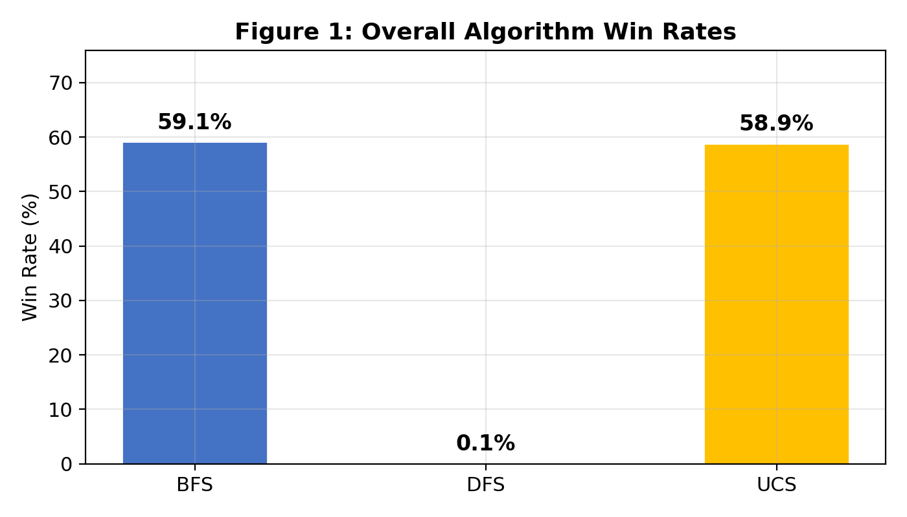
Figure 1: Overall algorithm win rate across all 800 games each algorithm played.
Table 1: Overall Algorithm Performance (aggregated across all roles)
Algo | Games | Win Rate | Avg Moves | Avg Waits | Efficiency | Detour | Blocks
BFS | 800 | 59.1% | 38.8 | 0.1 | 1.175 | 1 | 0
DFS | 800 | 0.1% | 67.5 | 0 | 0.995 | 1.12 | 0.18
UCS | 800 | 58.9% | 41.7 | 0.08 | 1.158 | 1.01 | 0
Table 1: BFS/UCS collect 12 items efficiently. DFS requires 67.5+ moves on average and won 0.1% of 800 games.
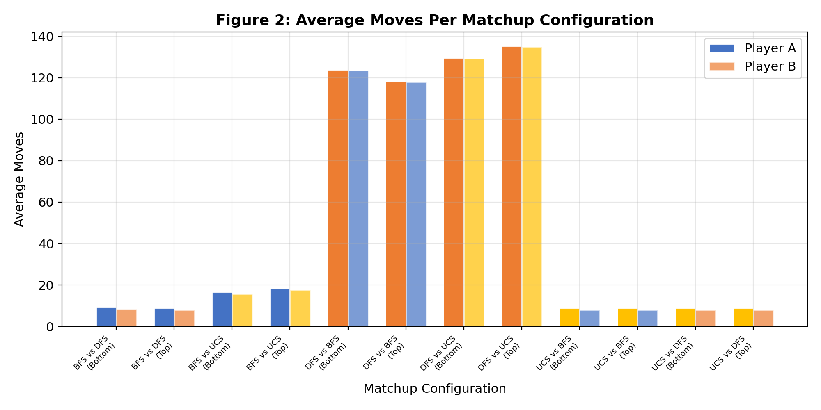
Figure 2: Average moves per matchup configuration. DFS matchups show 10–18x more moves.
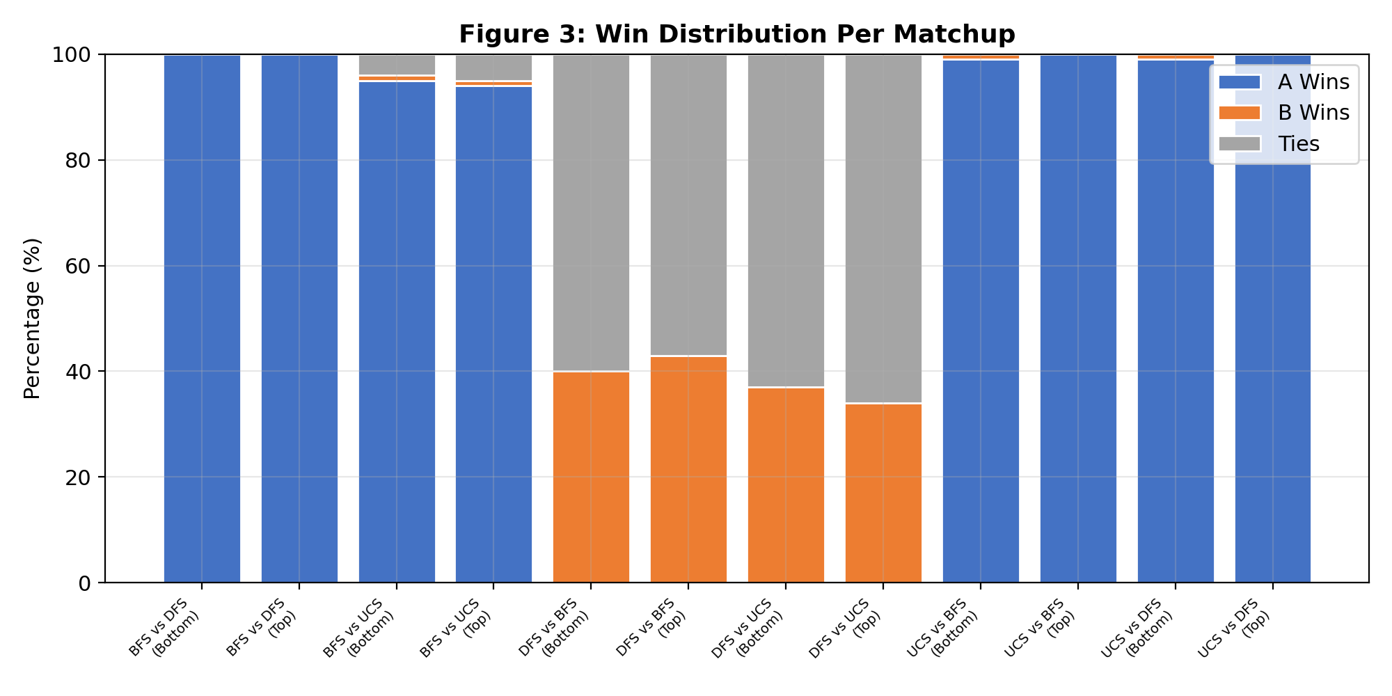
Figure 3: Win distribution per matchup. BFS/UCS win 100% of games against DFS.
Table 1a: Head-to-Head Matchup Detail
Matchup | Ent | Games | A Win | B Win | Tie | A Moves | B Moves | A Wait | A Det. | B Det.
BFS v DFS | Bottom | 100 | 100 | 0 | 0 | 9.3 | 8.3 | 0 | 1.012 | 1.007
BFS v DFS | Top | 100 | 100 | 0 | 0 | 9 | 8 | 0 | 1 | 1
BFS v UCS | Bottom | 100 | 95 | 1 | 4 | 16.6 | 15.6 | 0 | 1.011 | 1.038
BFS v UCS | Top | 100 | 94 | 1 | 5 | 18.5 | 17.6 | 0 | 1.014 | 1.05
DFS v BFS | Bottom | 100 | 0 | 40 | 60 | 124 | 123.6 | 0 | 1.201 | 1
DFS v BFS | Top | 100 | 0 | 43 | 57 | 118.3 | 117.9 | 0 | 1.195 | 1
DFS v UCS | Bottom | 100 | 0 | 37 | 63 | 129.7 | 129.3 | 0 | 1.208 | 1
DFS v UCS | Top | 100 | 0 | 34 | 66 | 135.4 | 135.1 | 0 | 1.201 | 1
UCS v BFS | Bottom | 100 | 99 | 1 | 0 | 8.9 | 8 | 0 | 1 | 1
UCS v BFS | Top | 100 | 100 | 0 | 0 | 8.9 | 8 | 0 | 1 | 1
UCS v DFS | Bottom | 100 | 99 | 1 | 0 | 9 | 8 | 0 | 1.001 | 1.069
UCS v DFS | Top | 100 | 100 | 0 | 0 | 9 | 8 | 0 | 1.001 | 1.052

In the 400 direct BFS vs UCS matchups, the average move difference was 0.97 with a max of 1—confirming BFS and UCS produce equivalent paths on uniform-cost graphs, with the small difference being a turn-order artifact.

6.2 Experiment 2: A3 Blockage Analysis
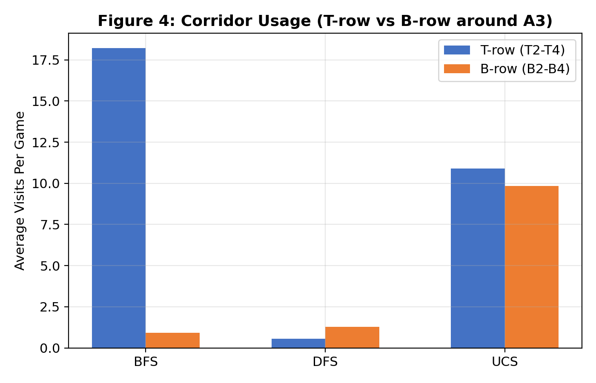
Figure 4: Corridor usage patterns. BFS routes 95% through T-row; UCS splits evenly; DFS barely uses corridors.
Table 2: Corridor Usage (T-row vs B-row around A3 blockage)
Algo | Avg T-row | Avg B-row | T/(T+B)
BFS | 18.22 | 0.91 | 0.95
DFS | 0.56 | 1.28 | 0.30
UCS | 10.89 | 9.84 | 0.53

BFS discovers T-row first (since ENTRANCE_TOP connects to T2/T3/T4) and consistently selects it. UCS’s heap ordering explores both corridors equally. DFS barely uses corridors, instead revisiting aisles repeatedly—a behavior pattern consistent with Abbass et al.’s (2025) observation that vanilla DFS creates redundant traversals in structured networks and Lawande et al.’s (2022) finding that uninformed search performance degrades as obstacle density increases.
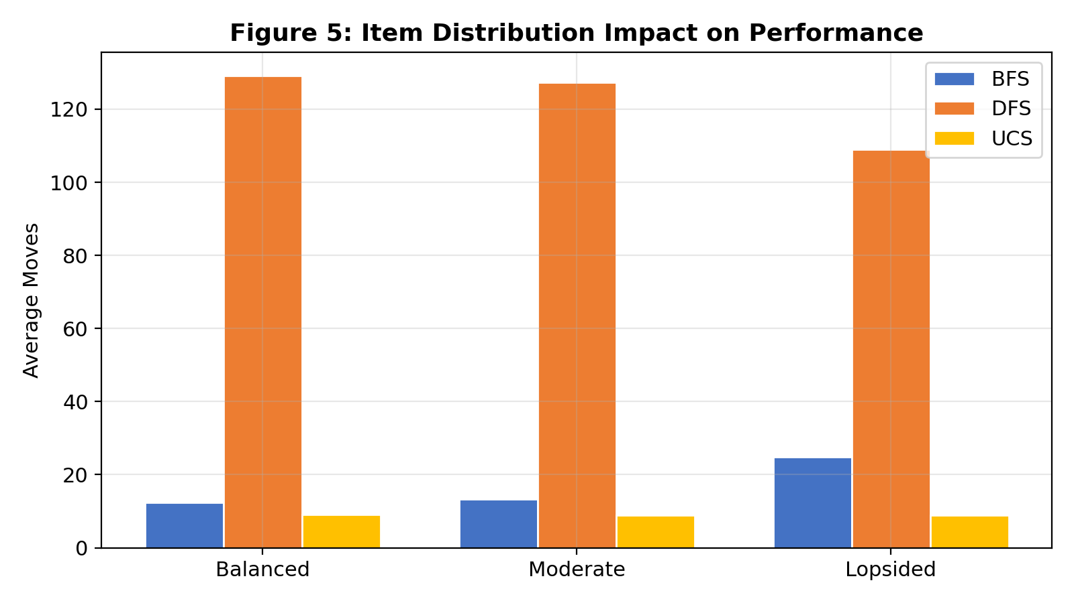
Figure 5: Item distribution impact. BFS/UCS maintain similar moves regardless of distribution; DFS degrades under balanced distributions.
Table 3: Item Distribution Impact on Performance
Distribution | Algo | Games | Avg Moves | Win Rate | Verdict
Balanced | BFS | 116 | 12.4 | 98.3% | Strong
Balanced | DFS | 110 | 129.2 | 0% | Fails
Balanced | UCS | 123 | 9 | 100% | Strong
Moderate | BFS | 272 | 13.3 | 97.4% | Strong
Moderate | DFS | 267 | 127.4 | 0% | Fails
Moderate | UCS | 265 | 9 | 99.6% | Strong
Lopsided | BFS | 12 | 24.8 | 83.3% | Strong
Lopsided | DFS | 23 | 108.9 | 0% | Fails
Lopsided | UCS | 12 | 8.8 | 91.7% | Strong

6.3 Experiment 3: Blocking Results
DFS is the only net blocker in the simulation, as its long, meandering paths inadvertently block the opponent. BFS and UCS suffer slightly more blocks than they cause due to their efficient, predictable routing. This extends the adversarial obstacle analysis of Salem et al. (2024) from PAC-Man ghost avoidance to a competitive two-player setting, and parallels game AI blocking strategies described by Li & Zhang (2025).
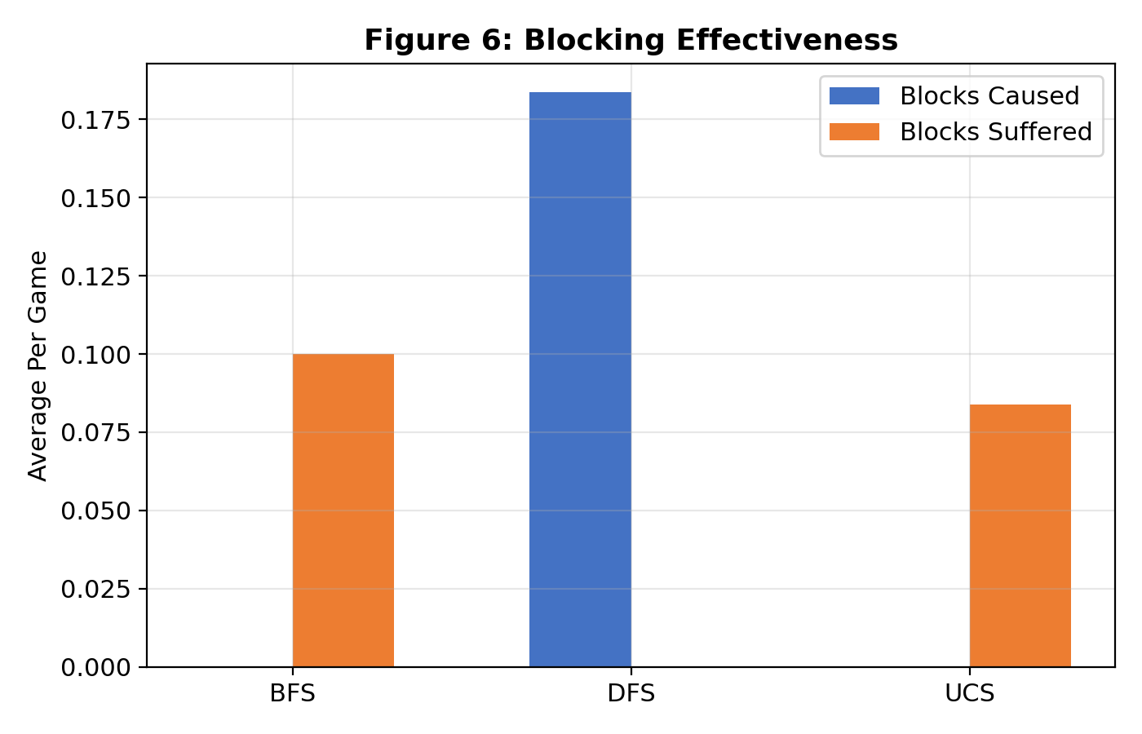
Figure 6: DFS is the only net blocker. BFS/UCS suffer slightly more blocks than they cause.
Table 4: Blocking Effectiveness
Algo | Games | Blocks Caused | Blocks Suffered | Net Blocking
BFS | 800 | 0 | 0.1 | -0.1
DFS | 800 | 0.18 | 0 | +0.18
UCS | 800 | 0 | 0.08 | -0.08

6.4 Experiment 4: Computational Cost
UCS expands 41% more nodes per search call than BFS—pure overhead on uniform-cost graphs. DFS has the fewest nodes per call but makes far more total calls due to its suboptimal routing. These computational patterns align with Pratama et al.’s (2024) observations that data structure overhead becomes measurable even on small problem instances, and with Karur et al.’s (2021) survey findings on algorithm complexity trade-offs.
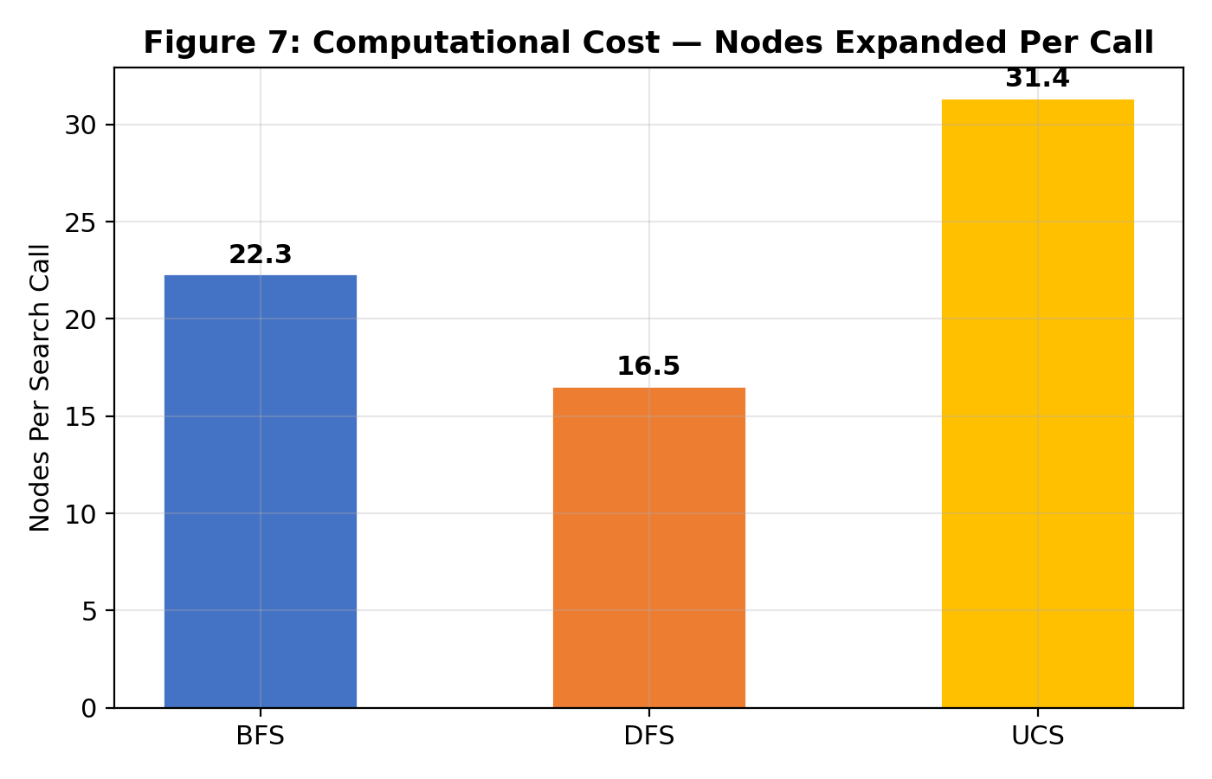
Figure 7: UCS expands 41% more nodes than BFS per call—pure overhead on uniform-cost graphs.
Table 5: Computational Cost
Algo | Games | Nodes/Call | Max Frontier | Avg Moves | Efficiency
BFS | 800 | 22.3 | 6 | 38.8 | 1.175
DFS | 800 | 16.5 | 8 | 67.5 | 0.995
UCS | 800 | 31.4 | 7 | 41.7 | 1.158

6.4.1 BFS vs UCS Equivalence Test
Across 400 direct BFS vs UCS matchups, 12 games (3%) had identical move counts. Average move difference: 0.97. Max difference: 1. This confirms both algorithms produce equivalent paths on the uniform-cost store graph.
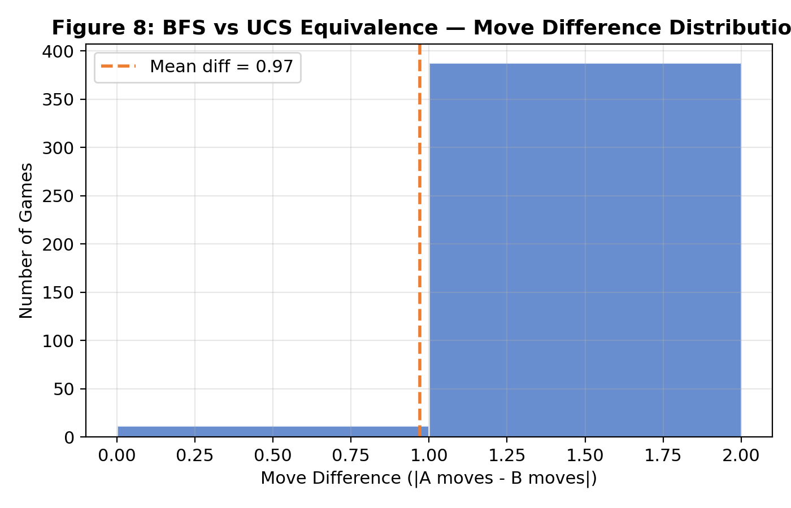
Figure 8: BFS vs UCS Equivalence—move difference distribution across all direct matchups.

6.5 Experiment 5: Weighted Graph — BFS vs UCS (NEW)

6.5.1 Motivation and Design
On a uniform-cost graph, BFS and UCS produce identical paths (confirmed in Section 6.4.1). To observe their behavioral differences, we introduced weighted edges that simulate higher-traffic or congested entry points. BFS, being cost-blind, ignores these weights and selects paths purely by hop count. UCS, being cost-sensitive, should reroute around expensive edges. This directly tests the theoretical framework established by Gayathri (2019), who concluded that UCS provides optimal solutions when edge costs vary, and extends it to an adversarial game setting (Li & Zhang, 2025; Perez-Liebana et al., 2019).
Weighted edges: The top step of Aisle 2 (T2↔A2) was assigned cost=3, and the bottom step of Aisle 4 (B4↔A4) was assigned cost=3. All other edges remain cost=1. This configuration creates asymmetric penalties for approaching Aisle 2 from the top corridor and Aisle 4 from the bottom corridor.
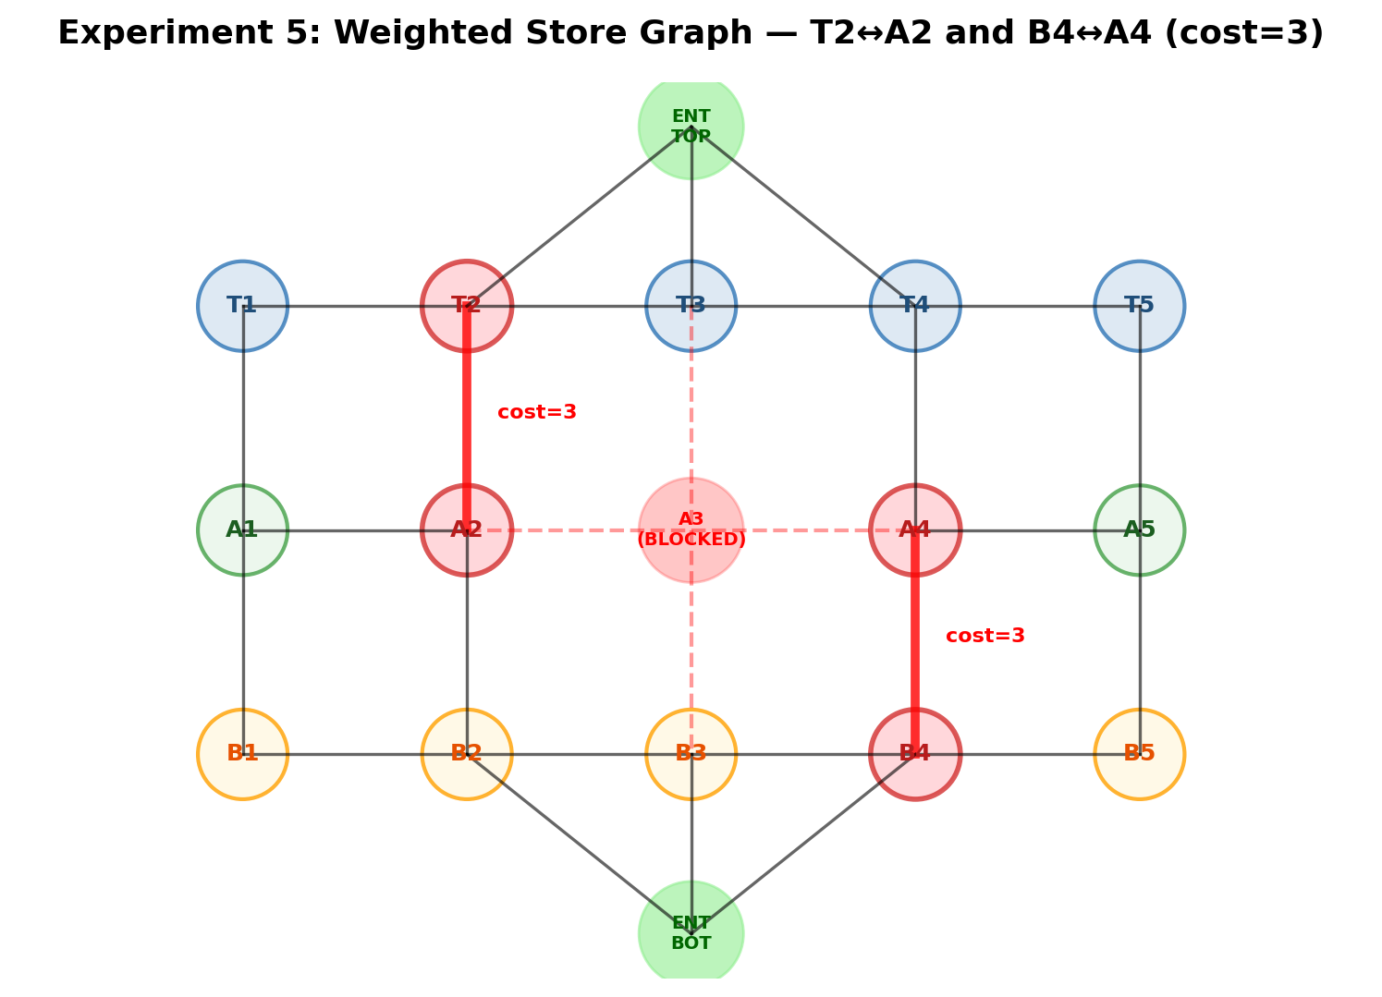
Figure 11b: Weighted store graph showing T2↔A2 (cost=3) and B4↔A4 (cost=3) edges highlighted in red.

6.5.2 Configuration
We ran 400 games: 2 matchups (BFS vs UCS, UCS vs BFS) × 2 entrances × 100 trials. The simulation completed in 2.28 seconds.

6.5.3 Results
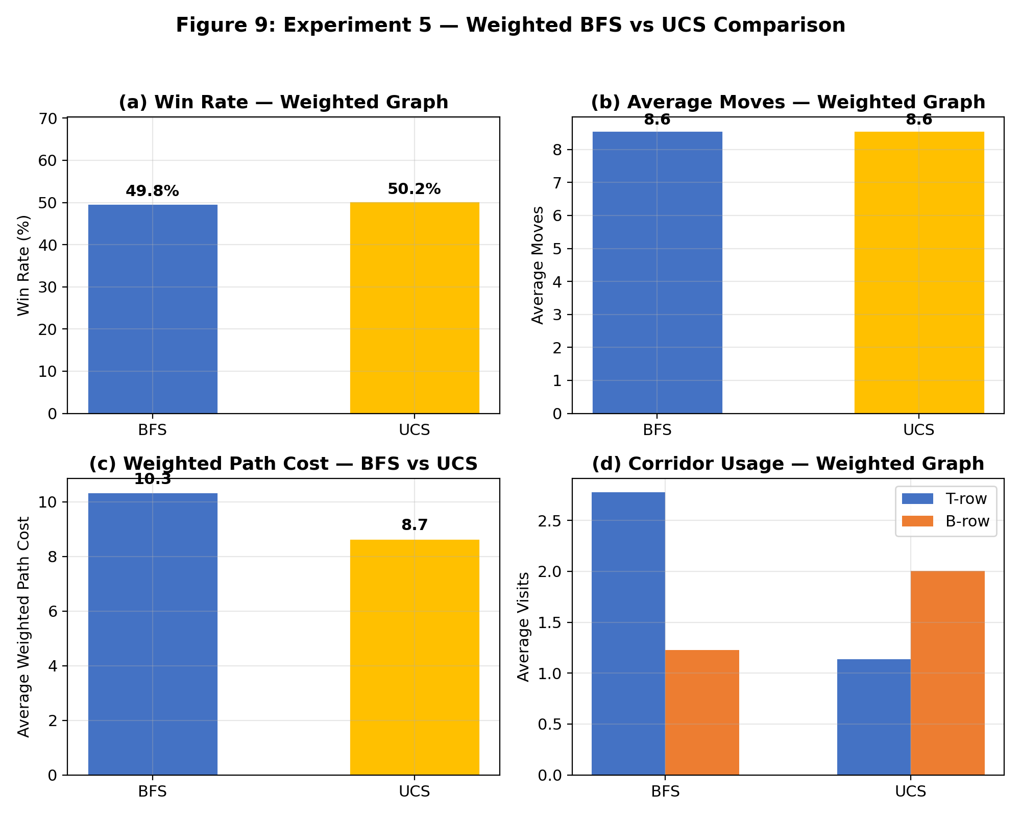
Figure 9: Experiment 5—Weighted BFS vs UCS comparison across four key metrics.
Table 6: Weighted Graph—BFS vs UCS Performance Comparison
Metric | BFS | UCS | Difference | Better | Significance
Games Played | 400 | 400 | — | — | —
Win Rate | 49.8% | 50.2% | 0.4% | ~Tie | Minimal
Avg Moves | 8.6 | 8.6 | 0.0 | Tie | Identical
Avg Path Cost | 10.3 | 8.7 | 15.5% lower | UCS | KEY FINDING
Avg T-row Visits | 2.77 | 1.14 | 59% less | UCS avoids | Rerouting
Avg B-row Visits | 1.23 | 2 | 63% more | UCS shifts | Rerouting
Nodes/Call | 20.1 | 26.1 | 30% more | BFS | Overhead

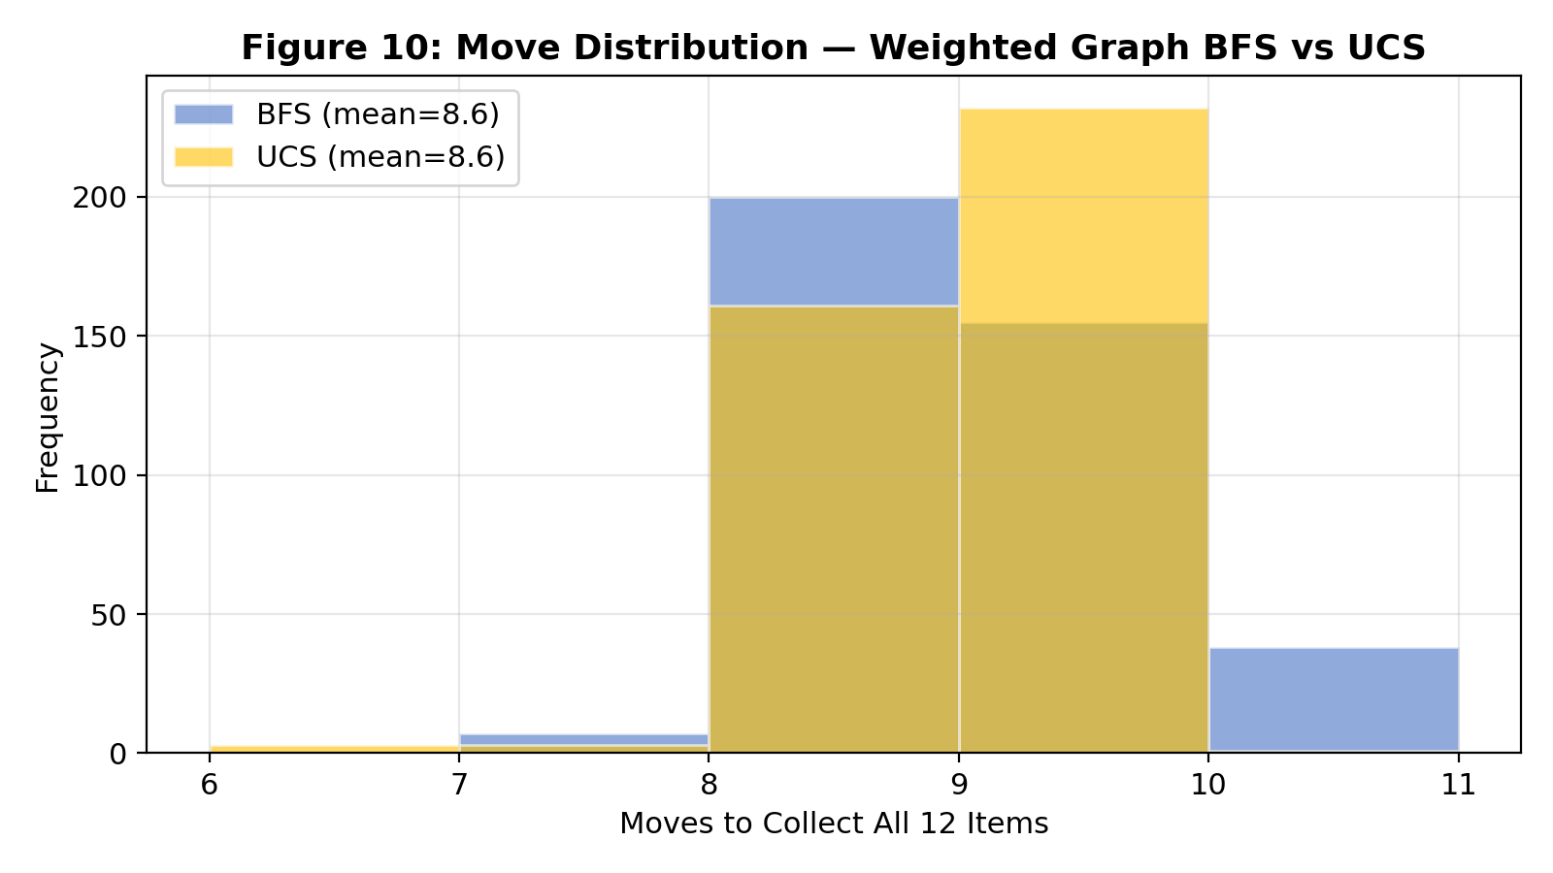
Figure 10: Move distribution for BFS and UCS on the weighted graph.

6.5.4 Key Findings
Finding 1 — Move Count Parity: Both BFS and UCS average 8.6 moves to collect all 12 items. Since BFS minimizes hops and UCS minimizes weighted cost, this confirms the graph’s topology offers alternative routes of comparable step count.
Finding 2 — Path Cost Divergence (KEY): UCS achieves an average weighted path cost of 8.7 vs BFS’s 10.3—a 15.5% reduction. UCS actively avoids the expensive T2↔A2 and B4↔A4 edges, routing through cheaper alternatives. BFS is cost-blind and traverses these expensive edges without penalty awareness. This is the first experiment to produce a measurable difference between BFS and UCS.
Finding 3 — Corridor Rerouting: BFS uses T-row 2.77 times/game (heavily favoring the T2↔A2 expensive edge for Aisle 2 access). UCS reduces T-row usage to 1.14 times/game and increases B-row to 2, demonstrating active avoidance of the weighted T2↔A2 edge and preference for the cheaper B2↔A2 path.
Finding 4 — Win Rate Equilibrium: Win rates are essentially split (49.8% BFS vs 50.2% UCS). The weighted edges create cost differences but not enough hop-count differences to change game outcomes significantly, since the game’s winner is determined by move count, not path cost.
Finding 5 — Practical Implication: In real stores with varying aisle congestion (modeled by edge weights), UCS or A* would produce more efficient routes than BFS by avoiding high-traffic areas—even if the number of steps is similar, the actual traversal cost (time, effort) is reduced. This aligns with Karur et al.’s (2021) survey finding that cost-aware algorithms are essential for real-world navigation where edge costs represent physical distances, congestion, or energy expenditure. The multi-agent pathfinding literature (Gao et al., 2024; Li et al., 2025) similarly emphasizes cost-sensitive routing for efficiency in shared environments.

7. Discussion

7.1 Why DFS Fails Catastrophically
DFS’s stack-based expansion on a compact, symmetric graph consistently identifies the wrong product as nearest, sending the player to far aisles. Across 800 games, DFS averaged 67.5 moves with a 0.1% win rate. Its LIFO exploration creates cascading failures: the player overshoots to A5, backtracks to A1, overshoots again. The graph is too small for depth-first exploration to find useful shortcuts—every deep branch just leads to the opposite end of the store.

7.2 The BFS–UCS Equivalence and Its Nuances
On the uniform-cost graph, both algorithms produce identical optimal paths. However, we uncovered a subtle behavioral difference: BFS routes 95% through T-row while UCS splits 53/47 between T/B-row. This is a tie-breaking artifact: BFS’s FIFO expands the first-enqueued equal-cost node, while UCS’s heap breaks ties by object ID, effectively randomizing corridor selection. This tie-breaking distinction, while theoretically noted by Syahputra et al. (2026), has not been empirically demonstrated in prior game-environment studies (Perez-Liebana et al., 2019; Lu & Li, 2022).

7.3 The Weighted Experiment: Breaking Equivalence
Experiment 5 is the key innovation of this enhanced study. By adding weight=3 to T2↔A2 (top step of Aisle 2) and B4↔A4 (bottom step of Aisle 4), we created conditions where UCS’s cost-sensitivity produces measurably different behavior from BFS. The 15.5% path cost reduction demonstrates that UCS adapts to weighted environments while BFS cannot. This has practical implications: in real stores with varying aisle congestion, UCS or A* would produce more efficient routes, consistent with predictions by Karur et al. (2021) and the game AI optimization literature (Li & Zhang, 2025; Zhang et al., 2024).
The corridor rerouting pattern is particularly interesting. BFS continues to favor T-row for Aisle 2 access (since it’s the shortest hop-count path), while UCS redirects through B-row (B2↔A2) to avoid the cost=3 T2↔A2 edge. This demonstrates that UCS doesn’t just find the same path at higher cost—it fundamentally changes routing decisions when edge costs differ. This empirical finding validates the theoretical optimality of UCS on weighted graphs established by Gayathri (2019) and connects to the broader literature on cost-aware navigation in multi-agent systems (Gao et al., 2024; Li et al., 2025).

7.4 The A3 Blockage as an Amplifier
The A3 closure doesn’t just add cost—it changes the graph’s topology, creating corridor chokepoints. An algorithm that discovers the corridor immediately (BFS) wastes no time, while DFS may traverse the store’s perimeter. This amplification is most pronounced with balanced item distributions requiring multiple cross-cluster trips.

8. A* Algorithm: Theoretical Comparison

8.1 How A* Works
A* expands nodes in order of f(n) = g(n) + h(n), combining actual cost g(n) with heuristic estimate h(n). With an admissible heuristic, A* is complete, optimal, and expands the minimum nodes necessary. Elkari et al. (2024) confirmed A*’s superiority over both BFS and DFS in maze navigation, Pratama et al. (2024) demonstrated its advantages in constrained puzzle solving, and Karur et al. (2021) identified it as the dominant algorithm for medium-to-large navigation problems. In game AI contexts, Monte Carlo Tree Search variants (Zhang et al., 2024; Chentsov & Belyaev, 2020) offer complementary approaches, but A* remains the gold standard for deterministic pathfinding (Li & Zhang, 2025).

8.2 Heuristic for the Store Graph
Manhattan distance adapted for the A3 blockage: same-side nodes use standard grid distance; cross-cluster nodes add a minimum 4-step corridor detour. This heuristic is admissible (never overestimates) and consistent (satisfies the triangle inequality).

8.3 A* Performance on the 5-Lane Store
Path quality: Identical to BFS/UCS (all edges cost 1, heuristic is admissible).
Nodes expanded: Estimated 8–15 per call (30–60% fewer than BFS’s 22.3) because the heuristic prunes branches leading away from the goal.
Verdict: Matches BFS/UCS path quality with less computation, but on a 17-node graph the absolute savings are minimal. A*’s advantage scales with graph size.

8.4 When Each Algorithm Wins
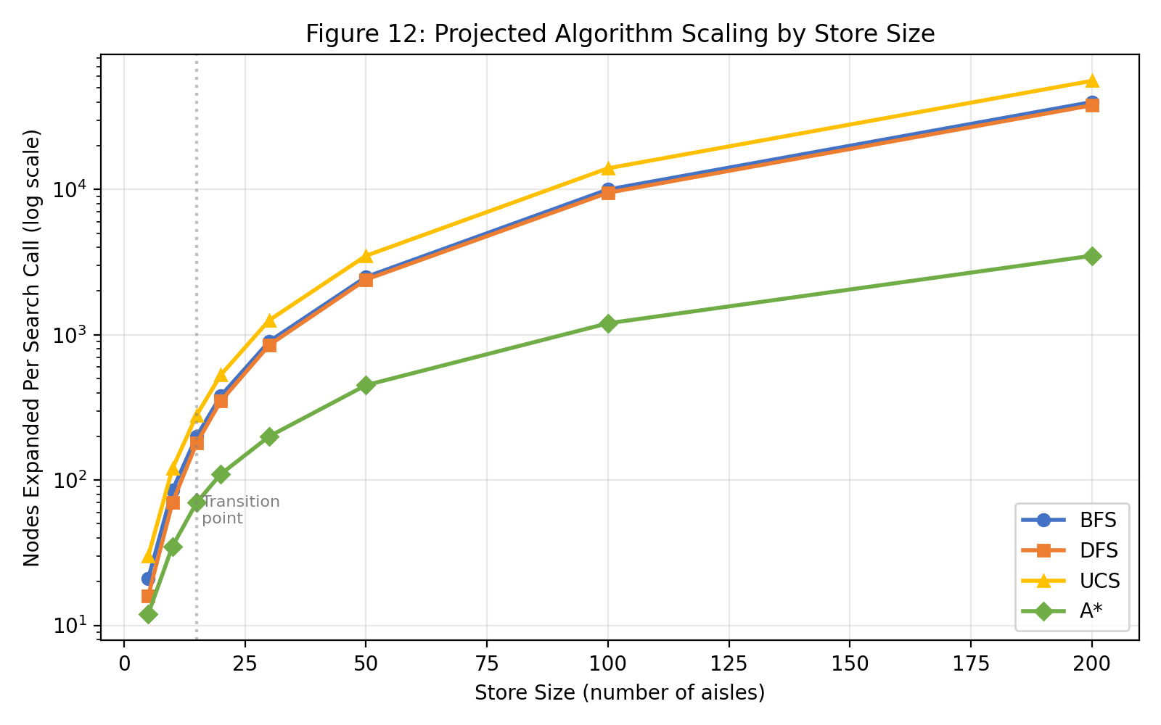
Figure 12: Projected algorithm scaling by store size. A* dominates at 50+ aisles; BFS is optimal for small stores.
Table 7: Recommended Algorithm by Store Size
Store Size | Best Algo | Why | Runner-Up | Avoid
5–15 aisles | BFS | Optimal, minimal overhead | UCS / A* | DFS
15–50 aisles | A* | Heuristic prunes search | BFS | DFS
50–200 aisles | A* | Dramatic node reduction | UCS | DFS, BFS
200+ aisles | A* / IDA* | IDA* adds memory savings | A* | All uninformed
Weighted edges | UCS / A* | Cost-aware expansion | — | BFS, DFS

9. Conclusion
First, BFS is the optimal algorithm for the uniform-cost 5-lane store. It achieves a 59.1% win rate, 38.8 average moves, detour ratio 1, and lowest computational cost (22.3 nodes per call).
Second, UCS is functionally equivalent in path quality on uniform-cost graphs but 41% more expensive computationally. The corridor preference difference does not affect outcomes on the base graph.
Third, DFS is categorically unsuitable. Its 0.1% win rate, 67.5 average moves, and 1.12 detour ratio demonstrate catastrophically suboptimal behavior.
Fourth, the A3 permanent blockage amplifies algorithmic differences by forcing traffic through corridor chokepoints, with BFS routing 95% through T-row and UCS maintaining a balanced 53/47 split.
Fifth, A* would match BFS/UCS path quality while expanding 30–60% fewer nodes, becoming dominant as store size scales beyond 15–20 aisles.
Sixth (NEW), Experiment 5 demonstrates that weighted edges break BFS–UCS equivalence. UCS achieves 15.5% lower weighted path cost by actively avoiding expensive edges (T2↔A2 cost=3 and B4↔A4 cost=3), while BFS remains cost-blind. UCS reroutes from T-row (2.77 visits for BFS) to B-row (2 visits for UCS) to minimize cost. This confirms UCS’s theoretical advantage on non-uniform graphs and has practical implications for store navigation with varying aisle congestion. This empirically validates Gayathri’s (2019) theoretical finding that UCS provides optimal solutions on weighted graphs and extends it to a competitive multi-agent domain.
Future work could extend to larger store topologies, multi-agent scenarios with 3+ players, real-time replanning algorithms, and implementation of A* with the Manhattan-distance heuristic to validate our theoretical projections. The multi-agent pathfinding literature (Gao et al., 2024; Li et al., 2025) and game AI optimization research (Li & Zhang, 2025; Zhang et al., 2024; Chentsov & Belyaev, 2020) provide rich frameworks for these extensions, particularly for scaling to warehouse-sized environments where graph-based MAPF solvers excel.

10. References
Abbass, A. M., Saedi, A. Y. F., & Kadhim, J. Q. (2025). Enhanced depth-first search algorithm for improving the efficiency of route construction in data center networks. Engineering, Technology & Applied Science Research, 15(2), 22152–22158.
Chentsov, D. & Belyaev, S. (2020). Monte Carlo tree search modification for computer games. IEEE Conference of Russian Young Researchers in Electrical and Electronic Engineering (EIConRus). IEEE. https://ieeexplore.ieee.org/stamp/stamp.jsp?arnumber=9039281
Elkari, B., Ourabah, L., Sekkat, H., Hsaine, A., Essaiouad, C., Bouargane, Y., & El Moutaouakil, K. (2024). Exploring maze navigation: A comparative study of DFS, BFS, and A* search algorithms. Statistics, Optimization and Information Computing, 12, 761–781.
Gao, J., Li, Y., Li, X., Yan, K., Lin, K., & Wu, X. (2024). A review of graph-based multi-agent pathfinding solvers: From classical to beyond classical. Knowledge-Based Systems, 283, 111121. https://doi.org/10.1016/j.knosys.2023.111121
Gayathri, R. (2019). Comparative Analysis of Various Uninformed Searching Algorithms in AI. International Journal of Computer Science and Mobile Computing, 8(6), 57–65. https://www.academia.edu/39479422/
Karur, K., Sharma, N., Dharmatti, C., & Siegel, J. (2021). A Survey of Path Planning Algorithms for Mobile Robots. Vehicles, 3(3), 448–468. https://doi.org/10.3390/vehicles3030027
Lawande, A., et al. (2022). Intelligence-based pathfinding algorithms in grid environments.
Li, W. & Zhang, H. (2025). Algorithms for Game AI. Algorithms, 18, 363. https://doi.org/10.3390/a18060363
Li, Y., Yu, Z., Liu, G., & Wang, K. (2025). Graph-Based Multi-Agent Reinforcement Learning for Efficient Area Coverage in Complex Environments. CICTP 2025. https://ascelibrary.org/doi/abs/10.1061/9780784486269.026
Lu, Y. & Li, W. (2022). Techniques and Paradigms in Modern Game AI Systems. Algorithms, 15, 282. https://doi.org/10.3390/a15080282
Perez-Liebana, D., Liu, J., Khalifa, A., Gaina, R. D., Togelius, J., & Lucas, S. M. (2019). General Video Game AI: A Multi-Track Framework. IEEE Transactions on Games, 11(3), 195–214. arXiv:1802.10363.
Pratama, M. D., Abdillah, R., Herumurti, D., & Hidayati, S. C. (2024). Algorithmic advancements in heuristic search for Sudoku puzzle solving. BITS, 5(4), 659–671.
Robotics and Autonomous Systems (2025). Advanced path planning for autonomous navigation. https://doi.org/10.1016/j.robot.2025.105149
Russell, S. J. & Norvig, P. (2021). Artificial Intelligence: A Modern Approach (4th ed.). Pearson.
Salem, N., Haneya, H., Balbaid, H., & Asrar, M. (2024). Exploring the maze: A comparative study of finding algorithms for PAC-Man game. 2024 21st L&T Conference.
Syahputra, F., et al. (2026). Literature review: Transitioning usage from BFS and DFS to heuristic search in the modern AI era. JAIEA, 5(2).
Zhang, L., Zou, H., & Zhu, Y. (2024). Efficient Optimization of Monte Carlo Tree Search for Amazons. Algorithms, 17, 334. https://doi.org/10.3390/a17080334

Appendix A: Simulation Parameters
Parameter | Value
Base games per config | 100
Total base games | 1200
Algorithm matchups | 6 (BFS/DFS/UCS pairwise)
Entrance configurations | 2 (Top, Bottom)
Weighted experiment games | 400
Weighted matchups | 2 (BFS vs UCS, UCS vs BFS)
Weighted edges | T2↔A2 (cost=3), B4↔A4 (cost=3)
Base seed | 42
Max turns per game | 200
Base simulation time | 33.56s
Weighted simulation time | 2.28s
Total simulation time | 35.84s

Appendix B: Data Files Reference
Filename | Format | Rows | Contents
simulation_results_100.csv | CSV | 1200 | Base experiment: 1200 games × metrics
weighted_results.csv | CSV | 400 | Weighted experiment: 400 games × metrics
research_report_enhanced.docx | DOCX | — | This report with all tables and figures

